eisy | OpenADR – OpenADR 2.0(a)/(b) Configuration Guide
*Requires firmware 5.6.2+

eisy Installation

You can connect eisy to your network either using WiFi or an Ethernet cable (not provided). In commercial settings, it would be easier to connect using an Ethernet cable.

Connecting to network using an Ethernet cable
Simply connect an Ethernet cable to your eisy’s network jack in the back. Note: the network must initially be DHCP enabled.
- No inbound ports or port forwarding rules are necessary

- The following outbound protocol/ports/URLs
  - TCP [HTTPS] to the Utility VTN URL/Port (please see section 3a)
  - Network Time Server [UDP] port 123 (if and only if not internal)

- The following outbound rule is necessary if and only if ISY Portal is used for remote access
  - TCP [HTTPS] to https://my.isy.io port 443

Connecting to network using WiFi

- Install UD Mobile on your Smart Phone and scan this QR Code:

- On the UD Mobile, click on the settings icon at the bottom right of the screen (gear icon) and then choose WiFi Configuration.
- You can also watch setup videos here.

Open the OpenADR Dashboard

Now that eisy is on the network, you can configure OpenADR Settings using your computer. Although most features of eisy are available on UD Mobile, OpenADR configuration still needs to be configure on your computer:
- If you do not have Java installed, please install the latest for your platform. You may find the latest Java downloads at http://www.java.com/getjava . Please choose the latest JRE for your platform.
- Click on this link to download the IoX Launcher. To launch, click on the downloaded start.jnlp file (usually in the Downloads folder). This should put an icon on your desktop once you run the downloaded start.jnlp file.
  - MAC Users: You will be prompted with a dialog warning you that you cannot open this application:
    - Go to System Preferences | Security & Privacy | General
    - Click on the open anyway button at the bottom
- Click on the discovered eisy and you will see this menu
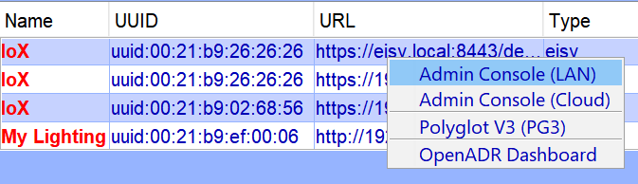
Figure 1 – IoX Launcher

  - Click on the Admin Console (LAN) menu item to perform the rest of the setup in this document. You can also use Admin Console (Cloud).
  - When prompted to authenticate, enter admin for both username and password
  - Once the Admin Console is up, click on the OpenADR | OpenADR Dashboard menu

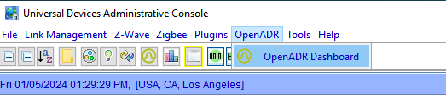

Figure 1.1 – Admin Console OpenADR Menu

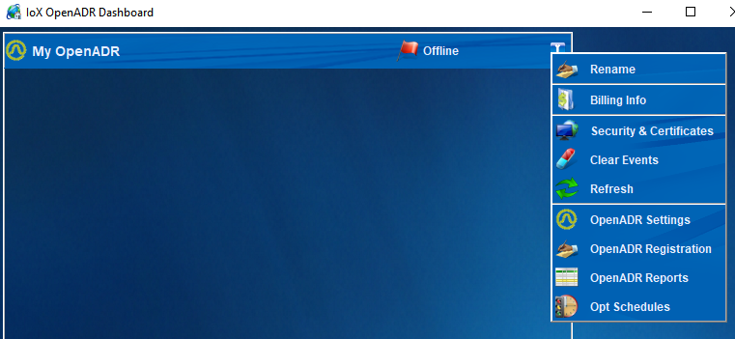
Figure 1.2 – OpenADR Dashboard & Menu

Install OpenADR Cert (if necessary)

- Make sure you have a valid OpenADR Certificate in .pfx (PKCS#12) format
- Click on Security & Certificates on My OpenADR Dashboard
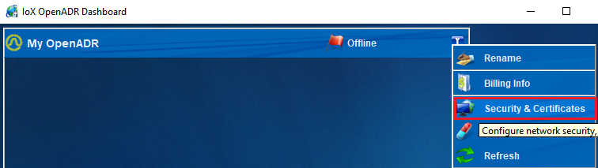

- Click on Client Certificate
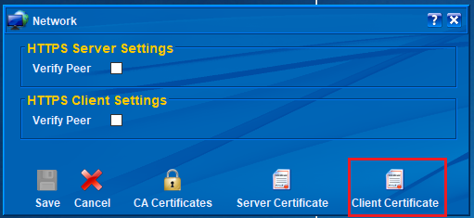
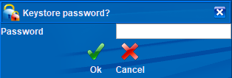
- Enter the password for the certificate.
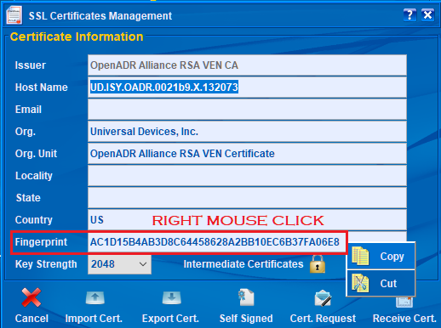

Configure OpenADR

Configure OpenADR Settings

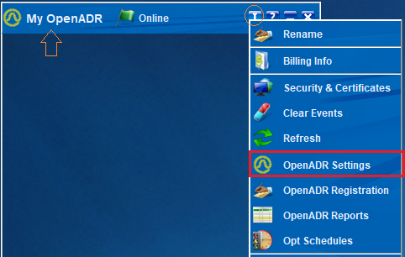

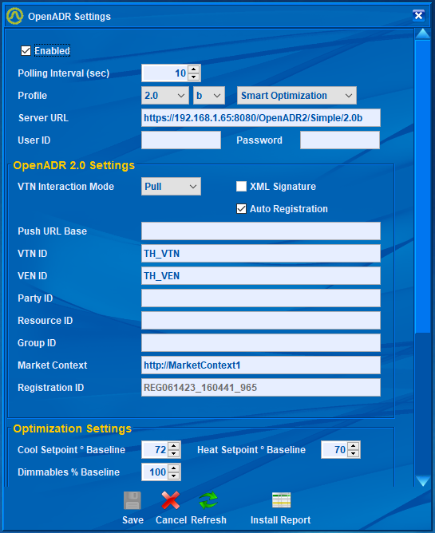

Configure OpenADR Registration (2.0b)

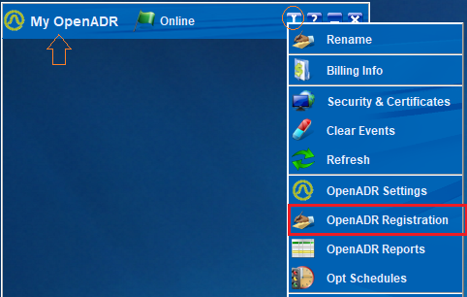
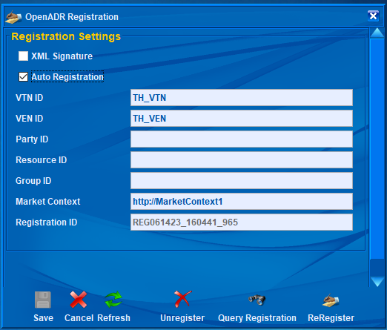

Auto Registration – if this option is checked, ISY will automatically try to register with the VTN at boot up or when there is no longer any registration.

Configure OpenADR Reports (2.0b)

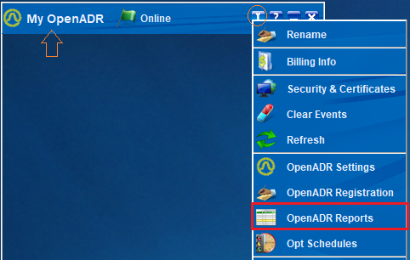
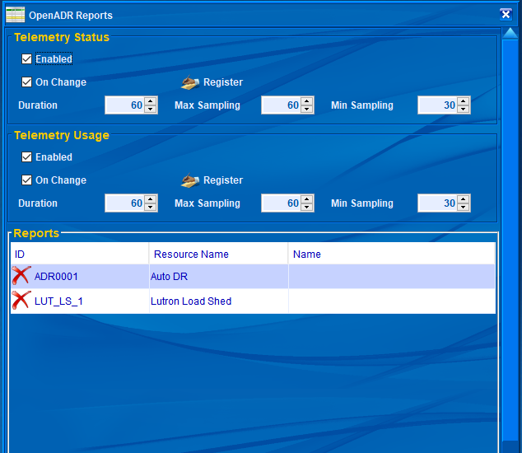
Register – All report types (status/usage) are registered at the same time regardless of which Register button is clicked.
Report registrations are cannot be canceled. So, if there are any changes to any reports, Register button must be clicked again to re-register all reports (replaces the old metadata information).
eisy will automatically decide what needs to be registered based on the device classes of devices that are in Auto DR group. For instance, energy monitoring channels only register Telemetry Usage whereas thermostats and load controllers register Telemetry Status. Some devices may report both.

Configure OpenADR Opt Schedules (2.0b)

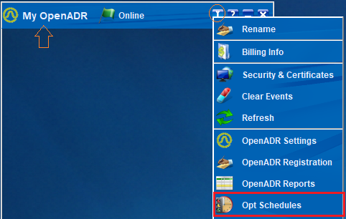

Opt Schedules inform eisy of what disposition must be reported during certain times. Clicking on the Add button or any of the schedules brings up the Opt Editor dialog which enables editing each schedule.
