ISY 994 Series
Energy Monitoring
Configuration Guide
supporting
Zigbee Brultech ECM1240
Zigbee UDI EM3

Based on firmware 3.3.1

Table of Contents

0.0 Revision History 3
1. Introduction 4
2. Getting Started 5
2.1 Configuring ISY 5
2.2 Configuring ECM1240 6
2.2.1 Connecting ECM to your Computer 6
2.2.2 Configuring ECM 7
2.3 Configuring UDI EM3 9
3. Nodes, Properties and Events 10
3.1 ECM 1240 Nodes 10
3.2 UDI EM3 Nodes 11
3.3 Events and Properties 12
3.4 Raw ECM140 Packet (control = _13 action = “7”) 13

0.0 Revision History
Date/Firmware | Type | Change | Description
2012/09/13  3.1.11 | DOC | Initial

Introduction

ISY994 Z Series incorporates sophisticated energy management capabilities to the base ISY platform supporting Zigbee Brultech ECM1240 and UDI’s EM3 3 Phase Energy Monitoring product. As such, all ISY interfaces, services, and events are applicable to 994Z as well.

ISY994 Z series comes equipped with an integrated high powered Zigbee radio operating on a Zigbee PRO stack. Utilizing the APIs, you can configure all parameters on Brultech ECM1240 and EM3 wirelessly and through Zigbee.

Upon startup, ISY either establishes a PAN (as a Coordinator) or starts operating on the PAN that was already established prior to reboot. It’s quite important to make sure that EM3 and ECM1240 are searching and joining the correct PAN and sending events to the correct end point. As such, there are two phases for the correct operation of the system:

- Setup ISY for a specific PAN ID and channel mask that is known not to interfere with other RF devices such as WiFi systems.
- ECM1240:
Setup so that ECM can search for the PAN ID configured in ISY, set source and destination endpoints, and ensure that ECM1240 is setup with the correct network and link keys (using encryption)
- EM3:
Setup so that EM3 can search for the PAN ID configured in ISY

Upon successful configuration, ECM1240 and EM3 automatically scan and join the PAN and starts publishing energy events.

Depending on the product, different nodes are added to the device tree representing each channel. As with the rest of ISY platform, you can use the REST interface to get properties for each node .

Getting Started

ISY994 Series is based on the same framework as ISY and therefore communications and event infrastructure follow the same paradigm.

ISY994 Z Series comes equipped with the energy monitoring module (MOD21011). If you have ISY994 Series, you will need to purchase this module through the Admin Console | Help | Purchase Modules.

Configuring ISY

Setup Zigbee network as depicted in Figure 1 below.

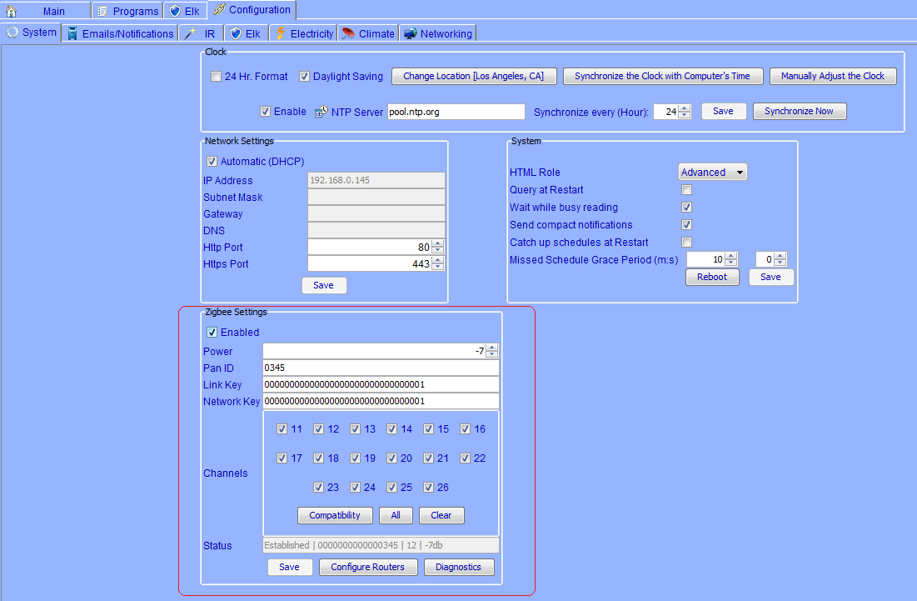
Figure 1. Setting up Zigbee Network

Note: If you are trying to communicate with ECM, make sure you click on the Compatibility button otherwise ECM may not find ISY.

Configuring ECM1240

As mentioned before, ECM1240 needs to be configured to scan for and join ISY. Since ISY uses Zigbee PRO, it’s important that the following parameters are set accurately.

You will need to configure ECM, through a serial port connected to your computer, to be able to communicate with ISY.

2.2.1 Connecting ECM to your Computer

- You will need to make a serial cable as shown in Figures 2A and 2B
- Depending on your computer, you may need a USB to Serial converter
- Download/Install ECM Config Util: http://www.etherbee.com/home/files/setup%20ECM-1240%20IA.exe
- Download/Install XCTU: XCTU 32-bit ver. 5.2.7.5 installer. More info on XCTU http://www.digi.com/support/kbase/kbaseresultdetl.jsp?kb=2125

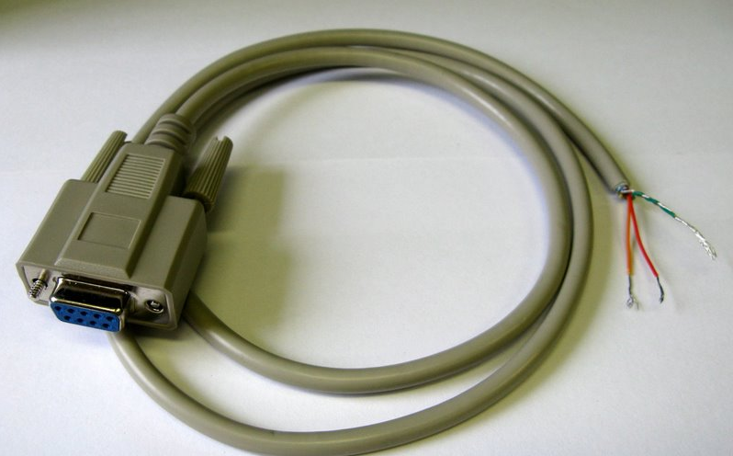
Figure 2A – Serial Cable

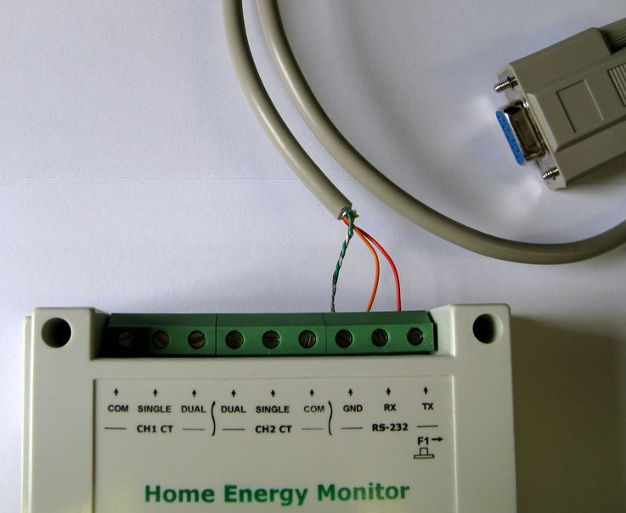
Figure 2B – Connect Serial Cable to ECM

2.2.2 Configuring ECM

- Open ECM Configuration Utility (Figure 2C)
  - On the Communications tab, enter the port number and then click Open Port … if everything is working you will see number of received packets right below
  - Go to XBee Commands tab, and then
    - Click on Stop Real Time button
    - Click on Serial to Xbee button (this will allow you to configure the Digi module using XCTU)
    - Click on ECM-1240 setup tab (at the top) and make sure Binary is chosen for the Packet Format (see Brultech.jpg)
  - Close the application
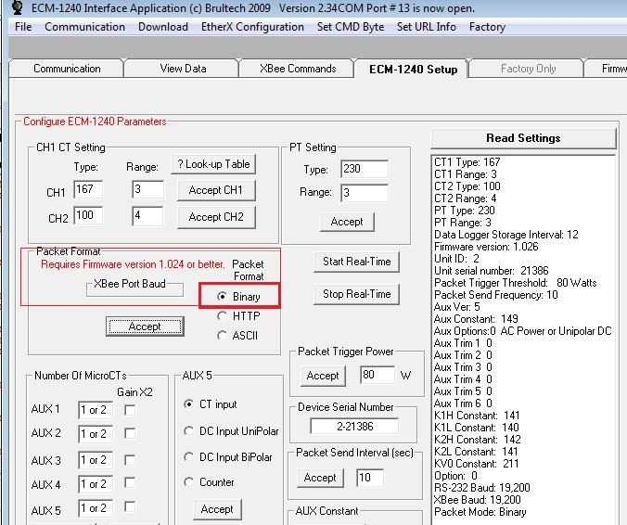
Figure 2C – ECM Configuration Utility

- Open XCTU
  - Choose the port ensuring that you have valid parameters (19200, None, 8, None, 1)
  - Click on the Test/Query button … this should bring you a dialog with Digi XB information
  - Click on the Terminal tab
    - Type: +++ …. This should give you an OK prompt; please note that each command you send to Digi is followed by an OK. If you do not see the OK, then enter +++ again. Timeout is about 10 seconds
    - Type: ATZS2 … followed by Enter; this tells Digi to use Zigbee PRO profile
    - Type: ATEE1 … followed by Enter; this tells Digi to use security
    - Type: ATKY1 … followed by Enter; this tells Digi to use Link Key of 1
    - Type: ATID345 …. Followed by Enter; this tells Digi to use PAN ID of 345 (this should be the same as PAN id in Admin Console | Configuration | Zigbee)
    - Type: ATDE2 … followed by Enter; this tells Digi to send events to our Endpoint #2
    - Type: ATWR … followed by Enter; this writes the configuration
    - Type: ATNR … followed by Enter; this restarts the network
  - Close application
  - Unplug Brultech, wait for a second, plug it back in

At this point, ECM1240 should start scanning for ISY with the given PAN ID and join it if found.

Configuring UDI EM3

UDI EM3 should automatically find ISY as long as the Network and Link Keys are set to 1 (see Figure 1).

Nodes, Properties and Events

Just like any other device in ISY, Energy Monitoring devices are represented as Nodes for each channel. Each node may have different properties (and associated events) all of which are easily retrieved using the same REST command used for other nodes in ISY:
/rest/nodes/<node_id>

This said, unlike INSTEON devices – and in addition to device category/sub category – one has to inspect the <family> element in the node:
7 – UDI EM3: defined in 7_fam.xml
8 – ECM 1240: defined in 8_fam.xml

ECM 1240 Nodes

ECM 1240 is represented by 7 nodes for 7 channels (See Figure 2). The address for the main node ends with 1.

For reference, the following table depicts the relationship between nodes, addresses, and properties:

Address <-> Channel | Supported Properties
1 1 | ST = Current Power  TPW = Current Energy  PPW = Polarized Power  CV = Current Voltage  CC = Current Current
2 2 | ST = Current Power  TPW = Current Energy  PPW = Polarized Power  CC = Current Current
3 3 | ST = Current Power  TPW = Current Energy
4 4 | ST = Current Power  TPW = Current Energy
5 5 | ST = Current Power  TPW = Current Energy
6 6 | ST = Current Power  TPW = Current Energy
7 7 | ST = Current Power  TPW = Current Energy

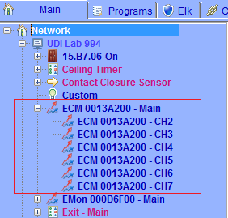

Figure 2 . ECM 1240 Nodes

UDI EM3 Nodes

UDI EM3 is represented by 11 nodes for 5 channels (See Figure 3), 3 temperature sensors and 2 pulse counters. The address for the main node ends with 1.

For reference, the following table depicts the relationship between nodes, addresses, and properties:

Address <-> Channel | Supported Properties
1 Main | ST = Current Power  TPW = Current Energy  For all channels
5 Channel 1 | ST = Current Power  TPW = Current Energy  PF = Power Factor  CV = Current Voltage  CC = Current Current
6 Channel 2 | ST = Current Power  TPW = Current Energy  PF = Power Factor  CV = Current Voltage  CC = Current Current
7 Channel 3 | ST = Current Power  TPW = Current Energy  PF = Power Factor  CV = Current Voltage  CC = Current Current
8 Channel 4 | ST = Current Power  TPW = Current Energy
9 Channel 5 | ST = Current Power  TPW = Current Energy
40 Local Temp. | ST
41 Remote Temp1 | ST
42 Remote Temp2 | ST
60 Pulse Counter1 | ST
61 Pulse Counter2 | ST

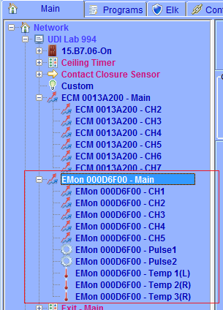

Figure 3. UDI EM3 Nodes

Events and Properties

The following events/controls/properties are defined for Energy Monitoring nodes. This said, not all nodes support all properties. One has to use /rest/nodes/<node_id> to inspect the supported controls:

TPW: Total Power (in kWh)
PPW: Polarized Power (in kWh)
PF: Power Factor
CC: Current Current (in Amps)
CV: Current Voltage (in Volts)
ST: Node dependent:
Energy Channel (in Watts)
Temp Sensor (in Degrees)
Pulse Counter (number of pulses)

Raw ECM140 Packet (control = _13 action = “7”)

node = null
<eventInfo>
[![CDATA]
Raw binary packet directly from Brultech]
</eventInfo>

